**Project Report**

**On**

**Profiling Tool Development**



*Submitted*

*In partial fulfilment for the award of the degree of*

# PG-Diploma in High Performance of Computing in Application

# Programming

**(C-DAC, ACTS (Pune))**

|  |  |
| --- | --- |
| **Guided By:** | **Submitted By:** |
| Mr. Om Jadhav | Sudhanshu Kamble (230340141028) |

Poonam Waghmare (230340141016)

Kothimbire Dipali (230340141012)

Abhijeet Shinde (230340141001)

Aditya Bhalavi(230340141002)

**Centre for Development of Advanced Computing**

**(C-DAC), ACTS (Pune- 411008)**

## Acknowledgement

This is to acknowledge our indebtedness to our Project Guide **Mr. Om Jadhav ,** C-DAC ACTS, Pune for her constant guidance and helpful suggestion for preparing this project **Profiling Tool Development.** We express our deep gratitude towards her for inspiration, personal involvement, constructive criticism that she provided us along with technical guidance during the course of this project.

We take this opportunity to thank Head of the department **Mr. Gaur Sundar** for providing us such a great infrastructure and environment for our overall development.

We express sincere thanks to **Mrs. Namrata Ailawar**, Process Owner, for their kind cooperation and extendible support towards the completion of our project.

It is our great pleasure in expressing sincere and deep gratitude towards **Mr.Himashu Sharma (Program Head)** and **Miss. Gayatri Pandit** (Course Coordinator, PG-DHPCAP) for their valuable guidance and constant support throughout this work and help to pursue additional studies.

Also, our warm thanks to **C-DAC ACTS Pune**, which provided us this opportunity to carry out, this prestigious Project and enhance our learning in various technical fields.

Poonam Waghmare (230340141016)

Kothimbire Dipali (230340141012)

Abhijeet Shinde (230340141001)

Aditya Bhalavi (230340141002)

Sudhanshu Kamble (230340141028)

## ABSTRACT

High-Performance Computing (HPC) has become instrumental in solving complex problems across various domains, such as scientific research, engineering simulations, and data analytics.. This project aims to explore the capabilities of five prominent profiling and optimization toolkits: HPCToolkit, Intel Advisor, Intel VTune, TAU, and LIKWID, in the context of enhancing the performance of HPC applications.

HPCToolkit is a comprehensive performance analysis suite that provides insights into program execution behavior, bottlenecks, and parallelism. Intel Advisor offers guidance for vectorization, threading, and memory utilization, helping developers tune their code for optimal performance. Intel VTune specializes in deep profiling, allowing developers to identify performance hotspots and memory usage patterns. TAU provides profiling and tracing capabilities across various programming models and platforms, while LIKWID focuses on low-level hardware performance analysis.

This project involves the creation of a script that integrates the capabilities of these toolkits into a unified workflow. The script streamlines the process of profiling and optimizing HPC applications, providing developers with a comprehensive toolkit to enhance application performance. By using this script, developers can effectively evaluate the performance characteristics of their HPC applications, identify bottlenecks, and implement targeted optimizations. In conclusion, this project demonstrates the power of combining various profiling and optimization toolkits to create a unified script for enhancing the performance of HPC applications.

**Table of Contents**

|  |  |  |
| --- | --- | --- |
| **S. No** | **Title** | **Page No.** |
|  | **Front Page**  **Acknowledgement**  **Abstract**  **Table of Contents** | **1**  **2**  **3**  **4** |
| **1** | **Introduction** | **5** |
| **2** | **Objective** | **6** |
| **3** | **Literature Review** | **7** |
| **4** | **Methodology and Techniques** | **8-11** |
| **5** | **Implementation** | **12-16** |
| **6** | **Results** | **17-20** |
| **7** | **Conclusion** | **21** |
| **8** | **Future Scope** | **22** |
| **9** | **References** | **22** |
|  |  |  |

**Introduction:**

In the realm of High-Performance Computing (HPC), the quest for optimal application performance is paramount. HPC applications tackle complex challenges spanning scientific research, engineering simulations, and data analysis, necessitating tools that delve into performance nuances. This project delves into five potent profiling and optimization toolkits – HPCToolkit, Intel Advisor, Intel VTune, TAU, and LIKWID – to empower developers in enhancing HPC application performance.

Each toolkit brings a unique perspective to the optimization landscape. HPCToolkit dissects program execution behavior, Intel Advisor guides vectorization and threading, Intel VTune explores deep performance profiling, TAU offers cross-platform profiling, and LIKWID delves into hardware performance metrics. The project crafts a script that merges these toolkits, simplifying profiling and optimization workflows.

The script automates instrumentation and profiling, integrates vectorization insights, unveils intricate performance metrics, and consolidates outputs. By amalgamating these analyses, developers gain a comprehensive view of application performance bottlenecks and avenues for optimization. This integrated approach offers a holistic solution for enhancing the efficiency of HPC applications, ultimately contributing to the advancement of high-performance computing capabilities.

**Objective :**

To Develop an advanced High-Performance Computing (HPC) profiling tool that enables comprehensive analysis and optimization of parallel and distributed applications, facilitating improved program performance and resource utilization.

The tool goes beyond basic profiling capabilities and offers comprehensive analysis features for developers in identifying performance bottlenecks, optimizing parallel execution, and making efficient use of computing resources.

The ultimate aim is to enhance the overall performance of HPC applications, leading to faster computations and better resource allocation.

**Literature Review:**

* **Intel Advisor**

The tool is designed to help programmers identify performance bottlenecks and provide insights into how to improve the efficiency of their applications.

* **HPCToolkit**

HPC Toolkit is a tool for measurement and analysis of program performance on computers ranging from multicore desktop systems to the largest GPU-accelerated supercomputers.

* **Intel VTune**

It empowers developers to enhance parallelism, and improve vectorization, resulting in faster and more efficient code execution.

* **TAU**

TAU(Tuning and Analysis Utilities) toolkit is a comprehensive profiling and tracing toolkit.

* **LIKWID**

LIKWID provides a set of tools and libraries which optimizes the performance of application.

**Methodology and Techniques:**

* **Problem identification:**

The HPC profiling toolkit aims to address the challenge of effectively optimizing High-Performance Computing (HPC) applications. Profiling plays a pivotal role in identifying performance bottlenecks, resource utilization issues, and areas for improvement within these complex applications

* **Tool Selection :**

The selection and integration of profiling tools such as hpctoolkit, Intel VTune, Intel Advisor, TAU, and LIKWID form the core of our approach. Each tool brings unique capabilities to the table, collectively offering a well-rounded analysis of HPC application performance. This integration enables users to gain insights into various aspects of their applications, including code execution, memory usage, parallelism, and hardware-level metrics. By combining these tools, we provide a cohesive solution that empowers users to comprehensively diagnose performance issues and optimize their HPC applications effectively.

* **Script Design and Automation :**

Our toolkit employs an automated script design to simplify the profiling process. We've developed individual scripts for each profiling tool and consolidated them into a single analysis script. This approach streamlines the user experience, automates the execution of multiple tools, and ensures consistent profiling across different aspects of HPC applications. With our automated script, users can initiate a comprehensive analysis effortlessly, saving time and effort while maintaining the accuracy of results.

* **Data Collection and Analysis Workflow:**

Our toolkit follows a seamless data collection and analysis workflow. Users execute the integrated analysis script, which orchestrates the execution of the individual profiling tools. The toolkit gathers performance data, including execution traces, hardware metrics, and memory usage statistics. Once the data is collected, it is processed and analyzed, generating insightful reports and visualizations. This workflow simplifies the complex process of profiling HPC applications, enabling users to swiftly identify performance bottlenecks and make informed optimization decisions.

* **Profiling Scenarios and Use Cases:**

Our toolkit caters to diverse profiling scenarios and use cases in the realm of HPC applications. Whether it's optimizing CPU-bound tasks, improving memory-intensive processes, or enhancing parallel code performance, our integrated solution offers tailored strategies for each scenario. By leveraging the capabilities of hpctoolkit, Intel VTune, Intel Advisor, TAU, and LIKWID, users can effectively address a wide range of performance challenges, making our toolkit a versatile asset for optimizing various aspects of HPC applications.

* **Interpreting Profiling Results:**

Our toolkit employs an automated script design to simplify the profiling process. We've developed individual scripts for each profiling tool and consolidated them into a single analysis script. This approach streamlines the user experience, automates the execution of multiple tools, and ensures consistent profiling across different aspects of HPC applications. With our automated script, users can initiate a comprehensive analysis effortlessly, saving time and effort while maintaining the accuracy of results.

* **Validation and Testing**

Our toolkit's functionality is rigorously validated through comprehensive testing. We assess its performance across a spectrum of HPC applications, comparing the results against those obtained from standalone usage of profiling tools. By verifying the consistency and accuracy of our toolkit's output, we ensure that users can confidently rely on the insights it provides. This validation process guarantees that our integrated solution effectively assists users in pinpointing performance bottlenecks and optimizing their applications with a high level of accuracy and reliability.

* **Performance Overhead Analysis**

We meticulously evaluate the performance overhead introduced by our toolkit during profiling. By conducting thorough benchmarking and measuring the impact on application execution, we ensure that the added overhead remains minimal. Our goal is to provide accurate insights while keeping interference with application behavior as low as possible. This approach guarantees that the profiling process does not compromise the accuracy of results and maintains the integrity of the application's performance characteristics.

* **Future Development and Enhancement**

Looking ahead, our toolkit's future development focuses on expanding its capabilities and usability. We plan to incorporate support for additional profiling tools, enhancing its compatibility with emerging HPC architectures. Additionally,

we aim to refine the automation process, streamline user interactions, and provide more advanced optimization recommendations. By continuously improving and adapting to evolving HPC landscapes, our toolkit remains a valuable resource for developers seeking to maximize the performance of their applications.

**Implementation:**

* **Intel Advisor Installation Script**

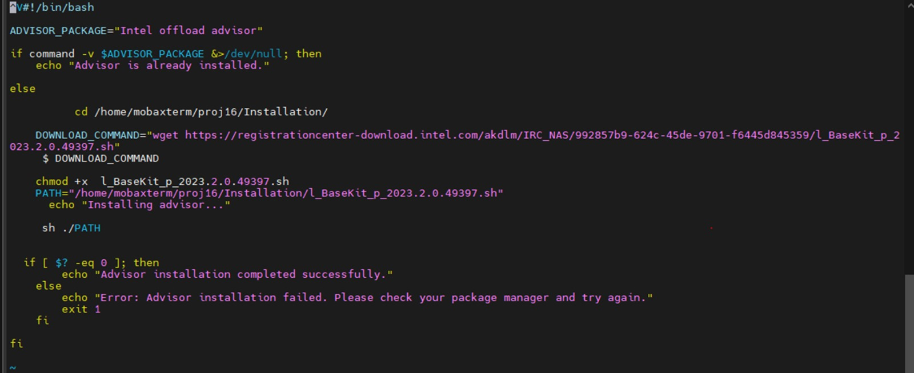

* **Intel Advisor Shell Script**

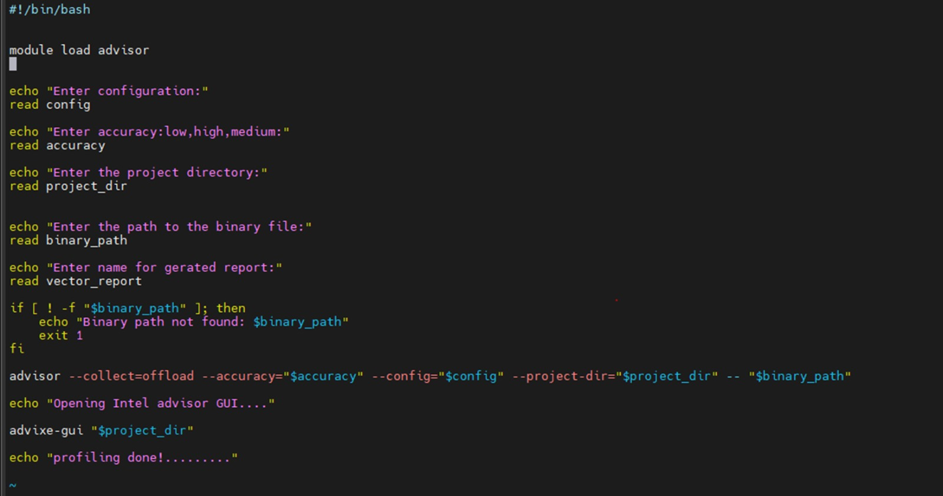

* **The shell script of hpctoolkit**

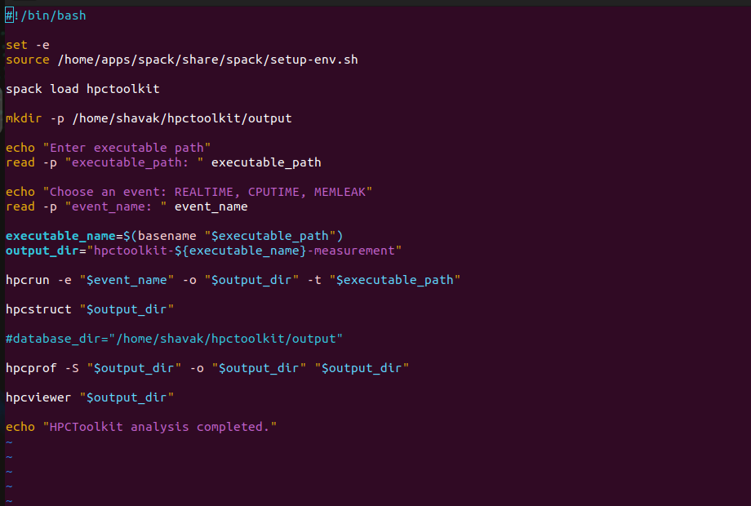

* **Vtune Installation Script**

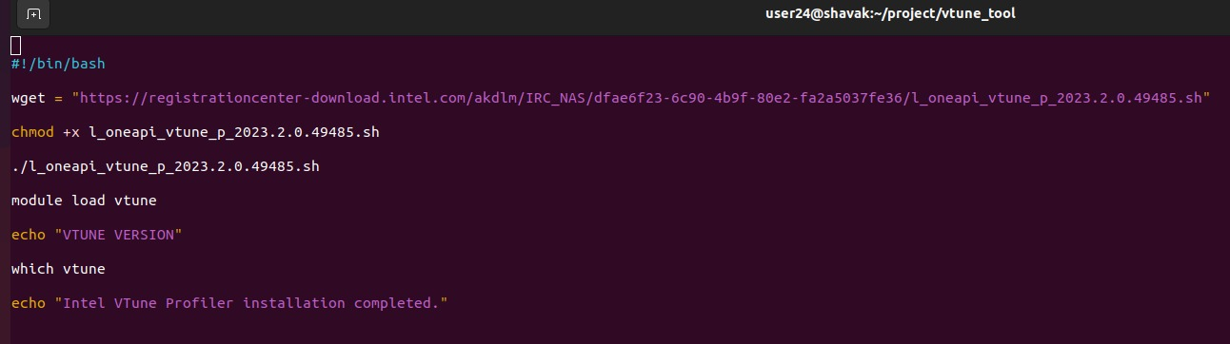

* **The shell script of Intel VTune**

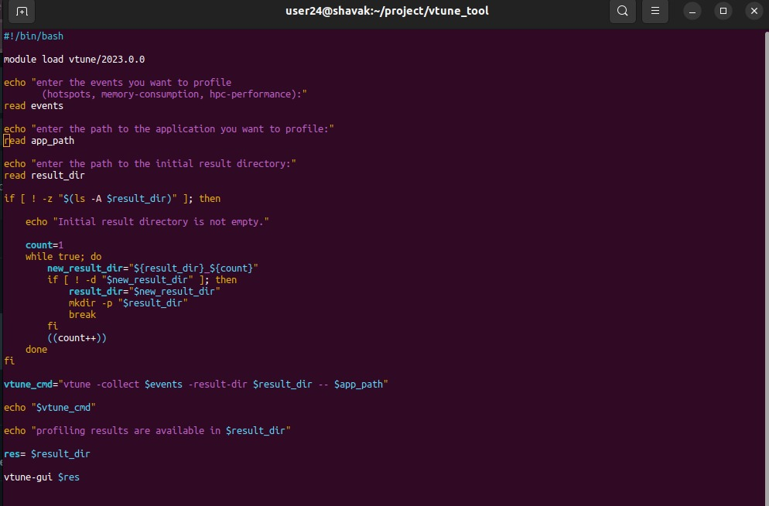

* **Tau Shell Script**

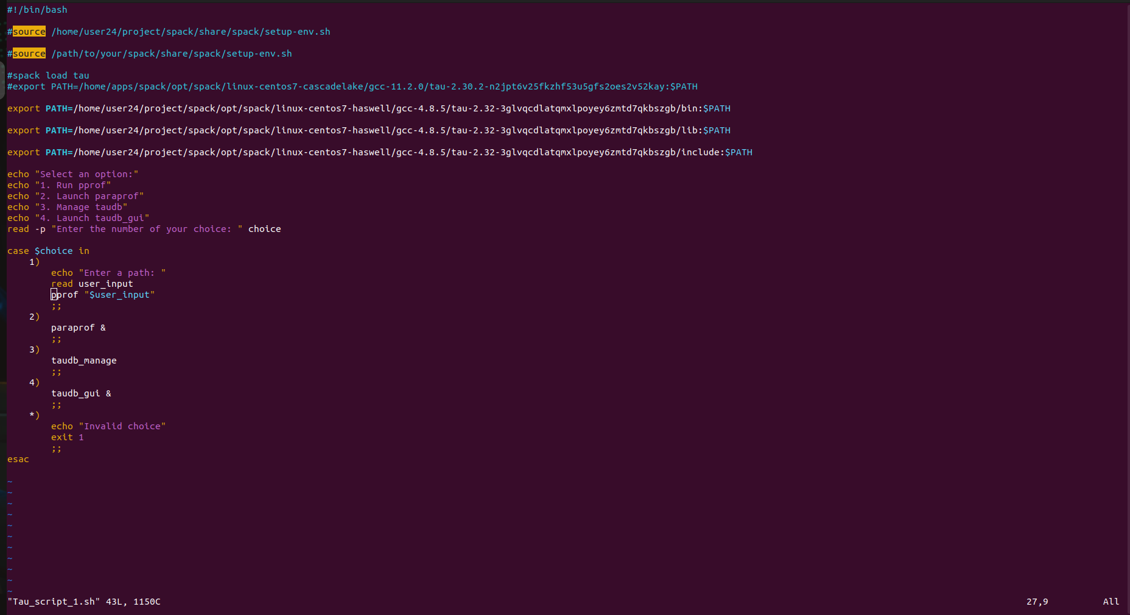

* **LIKWID Shell Script**

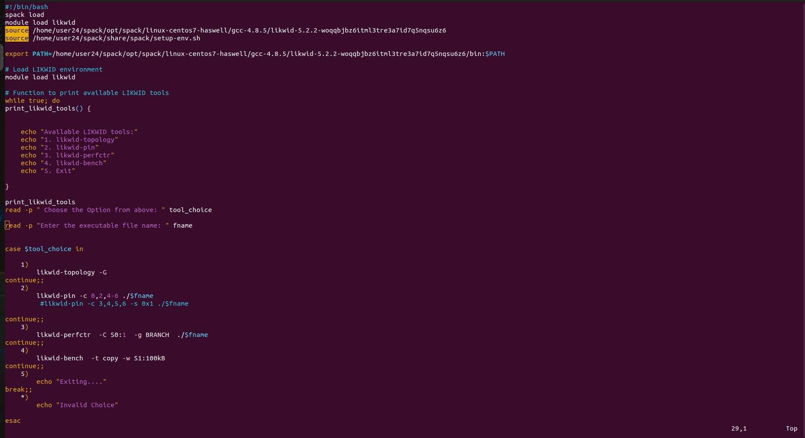

* **MAIN.sh**

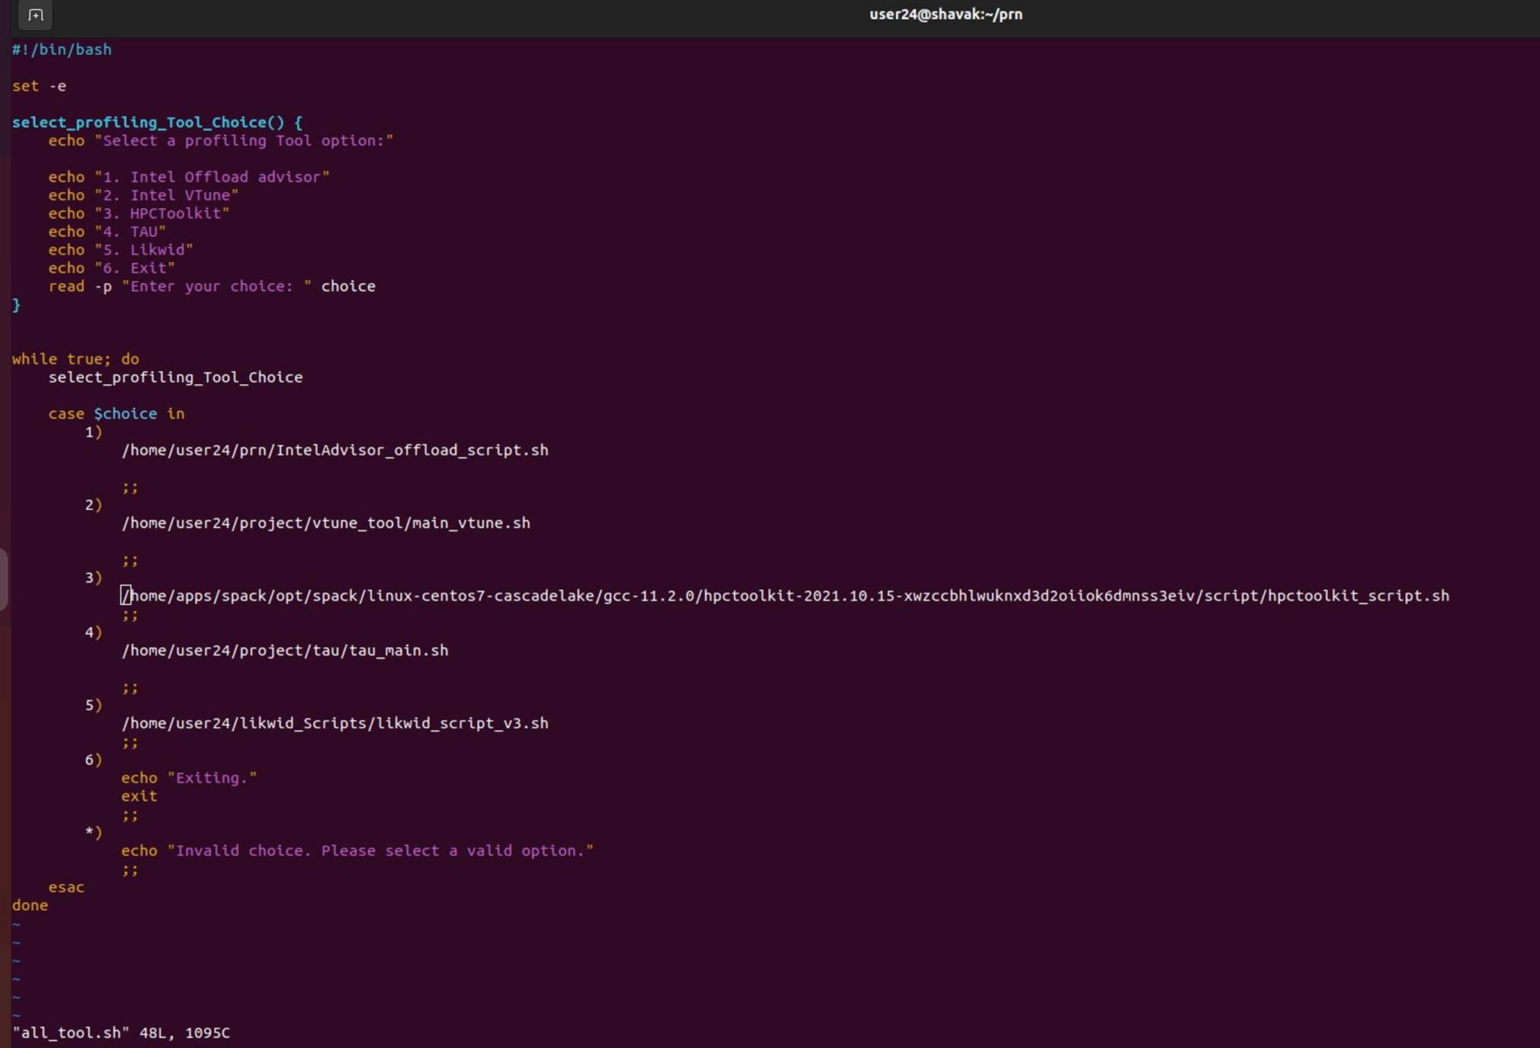

**RESULTS:**

* **IntelAdvisor**

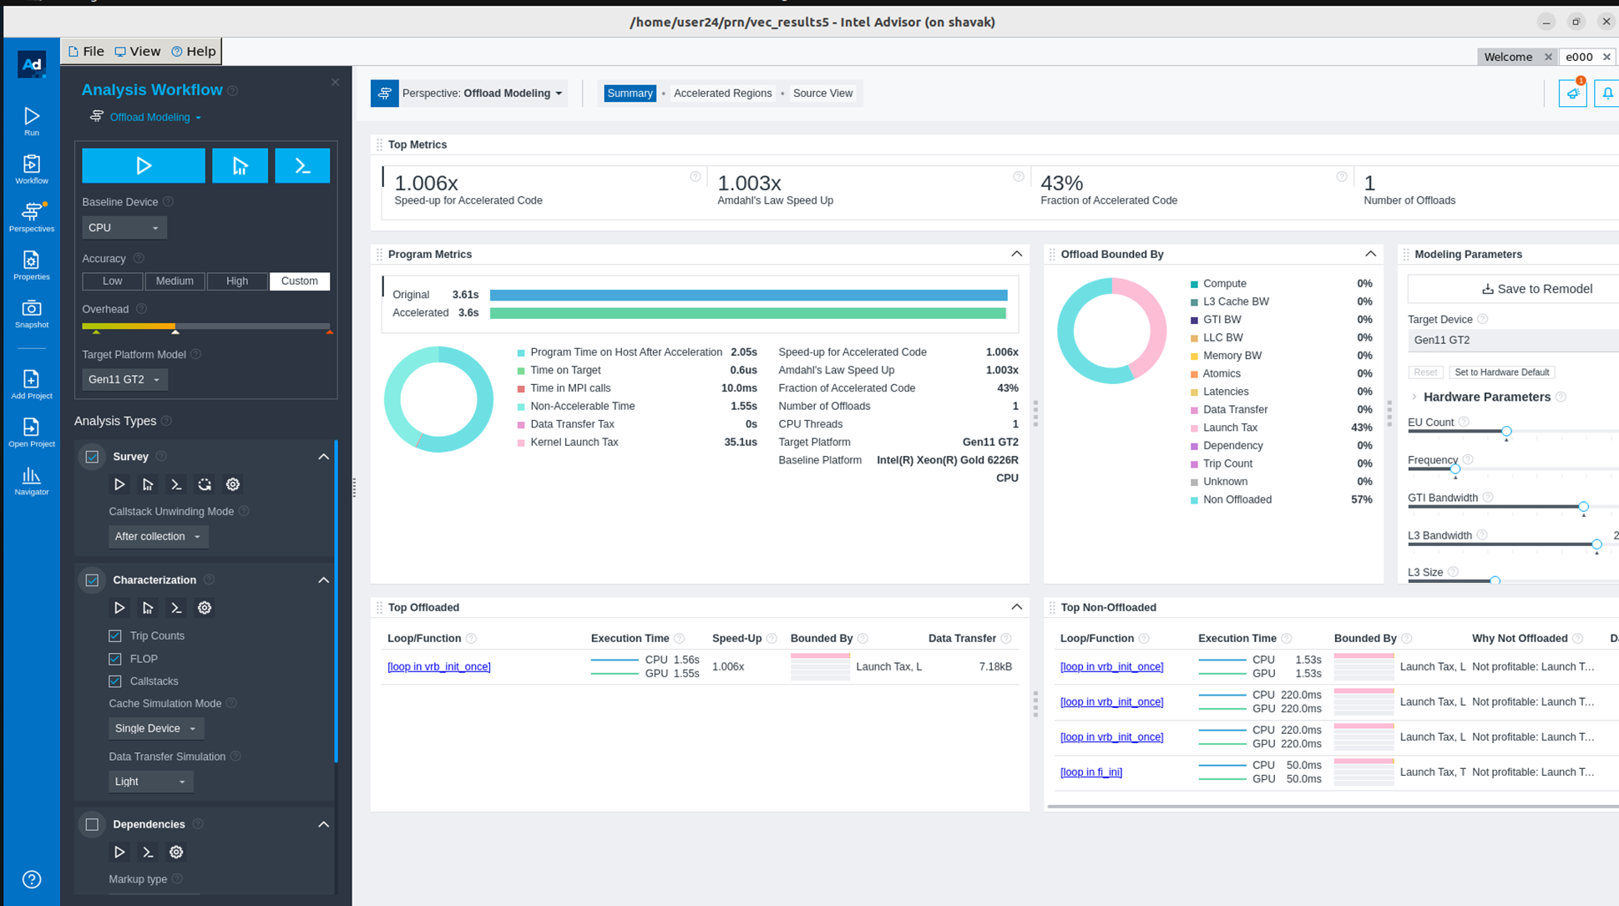

* **HPCTOOLKIT**

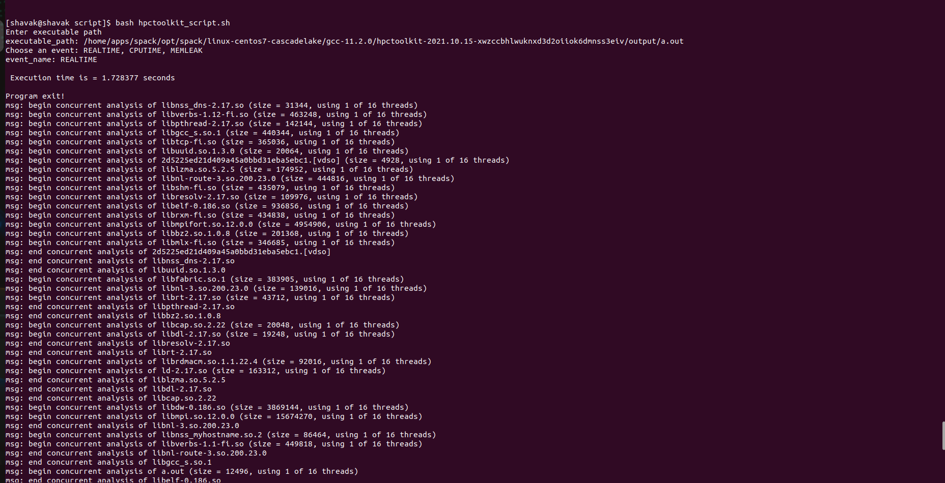

* **HPCTOOLKIT**

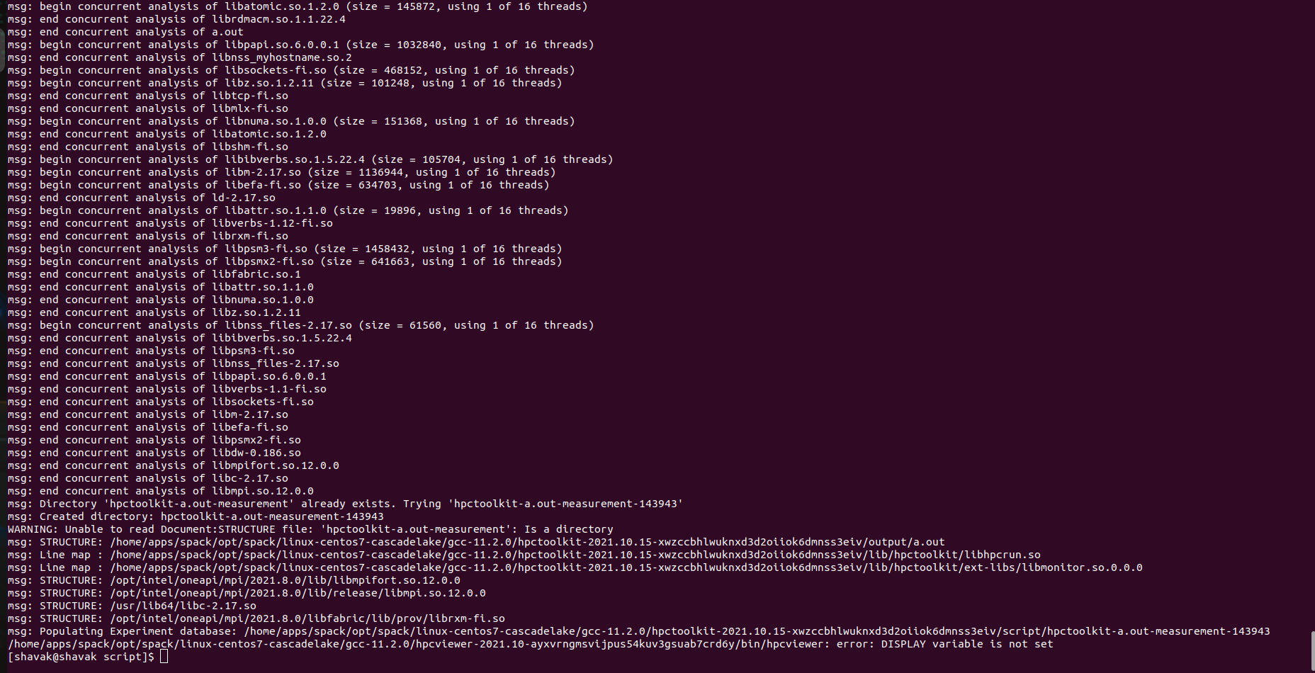

* **Intel Vtune**

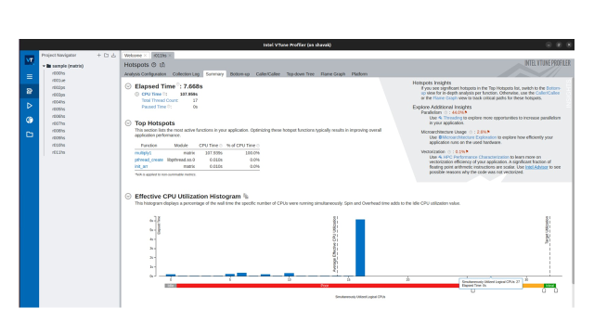

* **Intel Vtune**

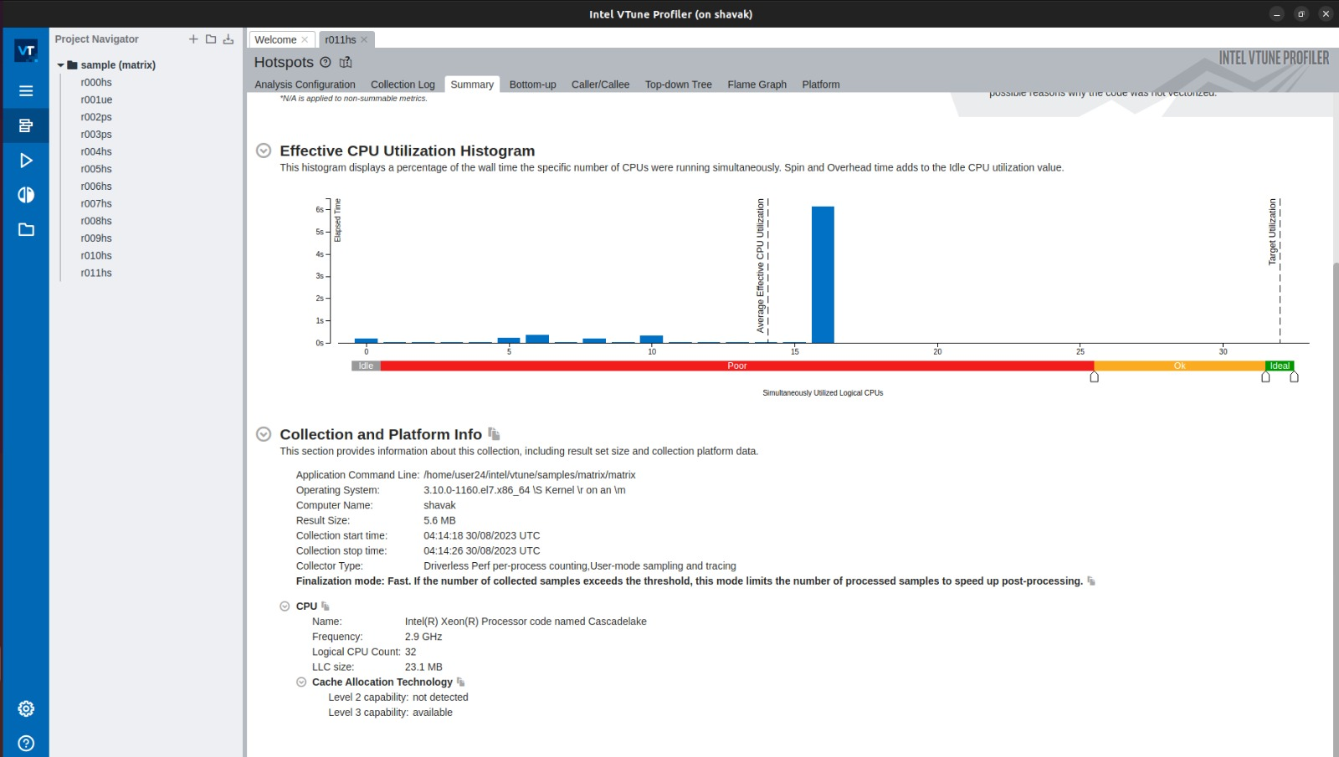

* **Intel Vtune**

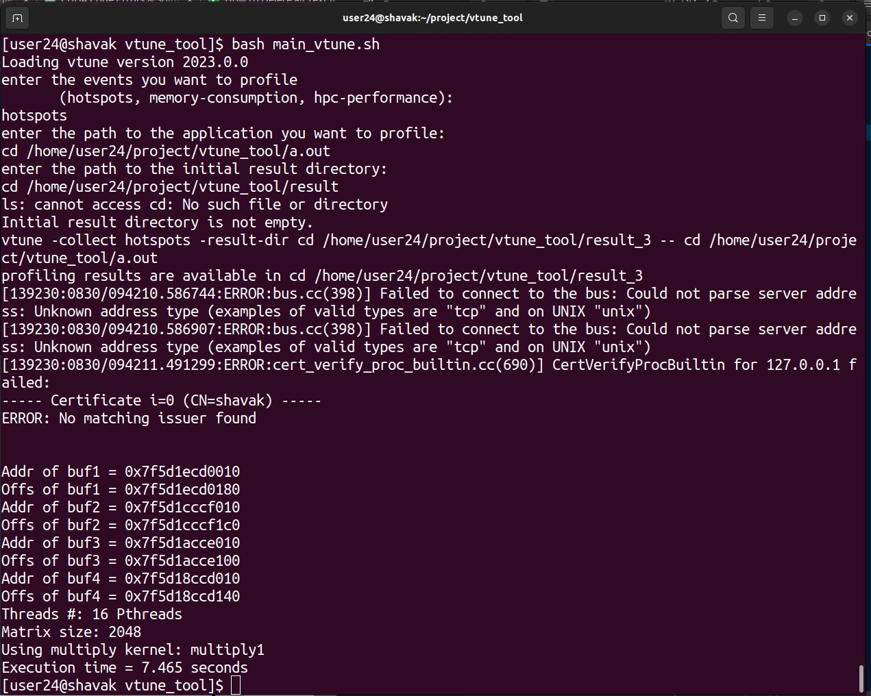

**Conclusion**

* In conclusion, the development of our profiling tool was an enlightening experience that allows us to develop one profiling toolkit that combines the features of five different toolkits we have used.
* The choice of a profiling tool depends on the specific goals, application domain, and hardware platform. Developers seeking to optimize performance should consider the features of these tools and choose the one that aligns best with their requirements.
* The project is not only expanded our understanding of profiling techniques but also the importance of selecting the right tool for the task.
* The ongoing evolution of these tools ensures that software developers have robust toolkit to analyze, optimize, and enhance the performance of their applications in an increasingly demanding computing landscape.

**Future Scope**

* Performance Portability: As software spans various hardware architectures, from traditional CPUs to GPUs, FPGAs, and accelerators, profiling tools will need to offer performance analysis across heterogeneous platforms.
* Tools that can analyze code behavior and performance on different architectures will be essential for optimizing applications for various target systems.
* Server less and Function-as-a-Service: These tools will help developers optimize server less functions for better execution times and resource utilization.

**References**

* <http://hpctoolkit.org/>
* <https://www.intel.com/content/www/us/en/developer/tools/oneapi/vtune-profiler.html#gs.4k990l>
* <https://www.intel.com/content/www/us/en/developer/tools/oneapi/advisor.html#gs.4k9a64>
* <https://hpc.llnl.gov/software/development-environment-software/tau-tuning-and-analysis-utilities>
* <https://www.cs.uoregon.edu/research/tau/home.php>
* <https://hpc-wiki.info/hpc/Likwid>
* <https://hpc.fau.de/research/tools/likwid/>
* <https://chat.openai.com/?model=text-davinci-002-render-sha>